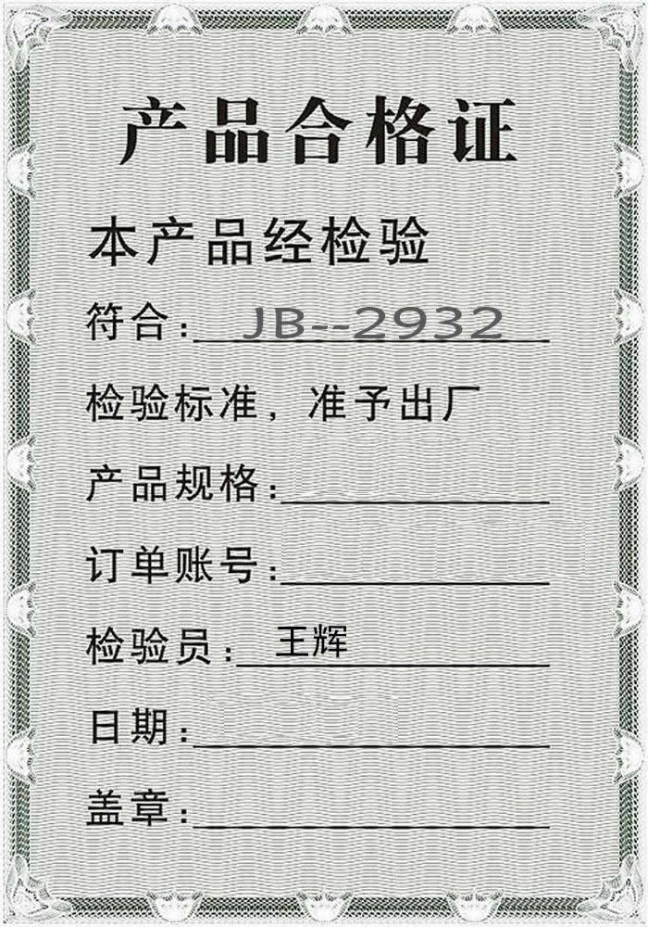
GQWTGS-1200
GQWTGS-2016-0411
2016-04-11

