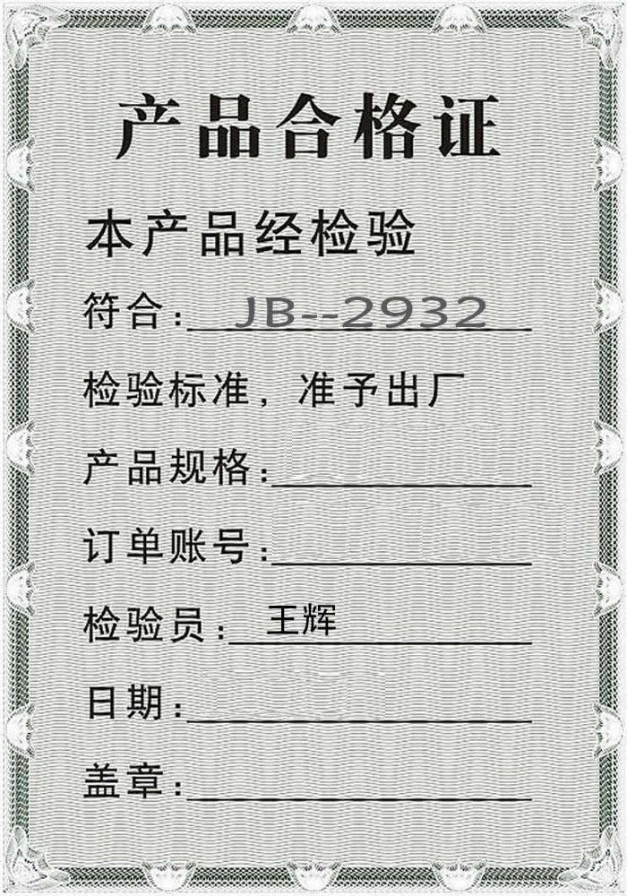
GQMF-50
GQWTGS-2014-0414
2014-04-16

